Custom Willow Classes Available
Full day
Workshops (indoor with specimens)
Outdoor Field Trips (location of your choosing)
or
a Combination of both!
Hire Gwen to train your team!
Learn from the expert!
Book Now
303-506-6480
Gwen.Kittel@Colorado.edu
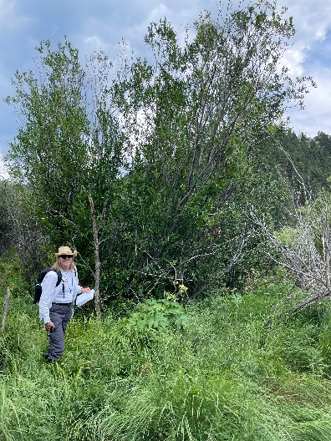
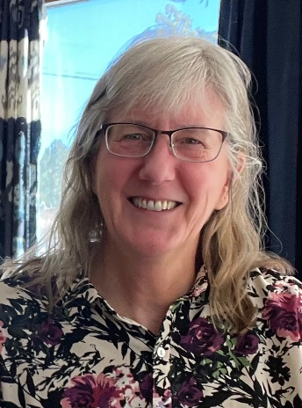
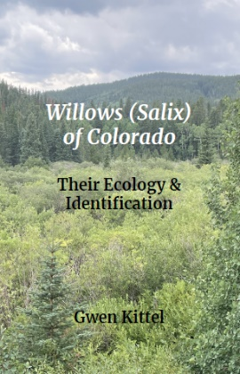
www.GwenKittel.com

